**Lab Assignment 4**

|  |  |
| --- | --- |
| **Roll No.: A055** | **Name: Ibrahim Shaikh** |
| **Program: B. Tech**-**CSBS (2ND YEAR)** | **Date of Release:**   16th August 2021 |
| **Batch:**  1/A | **Date of Submission:**  26th August 2021 |

**PROBLEM STATEMENT:**

**Problem Statement 1:** Electricity board wants to generate the monthly electricity bills for their consumers based on electricity units consumed. They apply following conditions to calculate the bill as per type of the consumer.

1. If Consumer type is “Commercial” then 5 Rs. per unit till first 200 units, after that 10 Rs. per unit for remaining units.
2. If Consumer type is “Non-commercial” then 3 Rs. per unit till first 100 units, after that 5 Rs. per unit for remaining units.

**Problem Statement 2:** Cricket control board would like to generate the list of all-rounder players for the selection in the cricket team based on following conditions.

1. Batting average should be more than 30
2. Bowling average should be below 25

**Following data members are used as player’s information.**

1. Name of the player (40 characters)
2. Name of the region (20 characters)
3. Batting average (float)
4. Bowling average (float)

**Following member functions will be used to perform this task**

1. readData() – will read the data all the players
2. generateList() – will prepare the list of common players whose batting average > 30 and bowling average < 25.
3. sortList() or other function()– will sort the list as per batting and bowling average separately
4. displayList() – will display both the lists of the players

Write main () function to implement the class and perform the operation.

**Concept to be implemented**: Array of objects and passing them to the member function as arguments.

**CODE:**

**Code for Problem Statement 1:**

#include <iostream>

#include <string.h>                   // for strcmp while comparing type

using namespace std;

class Consumer{

            char name[50], typ[15], bmon[10];

            int num, cmr, lmr;

            int amt,unit;

            public:

            void readData()

            {

                cout<<"\n\nEnter your Consumer name: ";

                cin>>name;

                cout<<"Enter your Consumer number: ";

                cin>>num;

                cout<<"Enter your Consumer type: ";

                cin>>typ;

                cout<<"Enter your Last Meter Reading: ";

                cin>>lmr;

                cout<<"Enter your Current Meter Reading: ";

                cin>>cmr;

                cout<<"Enter the Current Bill Month: ";

                cin>>bmon;

                unit = cmr-lmr; //for calculating unit of current month

            }

            void calculateBill()

            {

                if (strcmp(typ,"Commercial")==0)        // checking type

                {

                    if(unit<200 && unit>0)

                    amt=5*(unit);

                    else if(unit>=200)

                    amt=5*(200)+10*(unit-200);

                    else

                    cout<<"Enter a valid meter reading!!!\n";

                }

                else if (strcmp(typ,"NonCommercial")==0)    // checking type

                {

                    if (unit<100 && unit>0)

                    amt=3*(unit);

                    else if (unit>=100)

                    amt=3*(100)+5*(unit-100);

                    else

                    cout<<"Enter a valid Current meter reading!!!\n";

                }

                else

                cout<<"\nEnter a valid type!!!\n";

            }

            void printBill()

            {

                cout<<"The total Amount you need to pay is: "<<amt;

            }

};                          // class definition over

int main()

{

    Consumer c[10];        // object array declaration

    int n;

    cout<<"Enter the number of consumers: ";

    cin>>n;

    for(int i=0; i<n; i++)

    {

        c[i].readData();

        c[i].calculateBill();

        c[i].printBill();

    }

    return 0;

}

**Code for Problem Statement 2:**

#include <iostream>

#include <string.h> // for strcpy

using namespace std;

class CCB{

    char rname[20];

    float baavg, boavg;

    public:

    char pname[40];

    void readData() // for reading user input

    {

        cout<<"\nEnter the Player's Name: ";

        cin>>pname;

        cout<<"Enter the name of the Region of Player: ";

        cin>>rname;

        cout<<"Enter the Player's Batting Average: ";

        cin>>baavg;

        cout<<"Enter the Player's Bowling Average: ";

        cin>>boavg;

    }

    void generateList() // for displaying All Rounders

    {

        if(baavg>30 && boavg<25)

            {

                cout<<pname<<endl;

                cout<<baavg<<endl;

                cout<<boavg<<endl<<"\n";

            }

    }

    void displayList() //Display all players

    {

        cout<<"Player's Name: "<<pname<<"\n";

        cout<<"Region: "<<rname<<"\n";

        cout<<"Batting Average: "<<baavg<<"\n";

        cout<<"Bowling Average: "<<boavg<<"\n\n";

    }

    void sortbaList(CCB p[], int n) //sort accd. To Batting Avg

    {

        char temp[40];

        for(int i=1; i<n; i++)

        {

            for(int j=1; j<n; j++)

            {

                if(p[j-1].baavg>p[j].baavg)

                {

                    strcpy(temp,p[j-1].pname);

                    strcpy(p[j-1].pname,p[j].pname);

                    strcpy(p[j].pname,temp);

                }

            }

        }

        cout<<"\nNames Sorted according to Batting Average: \n";

        for(int i=0; i<n; i++)

        {

            cout<<"\n"<<"Player Name: "<<p[i].pname<<"\n";

            cout<<"Batting Average: "<<p[i].baavg<<"\n";

        }

    }

    void sortboList(CCB p[], int n) //Sort accd. To Bowling Avg

    {

        char temp[40];

        for(int i=1; i<n; i++)

        {

            for(int j=1; j<n; j++)

            {

                if(p[j-1].boavg>p[j].boavg)

                {

                    strcpy(temp,p[j-1].pname);

                    strcpy(p[j-1].pname,p[j].pname);

                    strcpy(p[j].pname,temp);

                }

            }

        }

        cout<<"\nNames Sorted according to Bowling Average: \n";

        for(int i=0; i<n; i++)

        {

            cout<<"\n"<<"Player Name: "<<p[i].pname<<"\n";

            cout<<"Bowling Average: "<<p[i].boavg<<"\n";

        }

    }

};

int main()

{

    CCB c[10];

    int n, ch;

    while (ch!=0)       //while loop for keeping on taking the input until user manually exits be pressing '0' when asked

    {

    cout<<"\nMENU\n";

    cout<<"1. Add Players\n";

    cout<<"2. Display List of all Players\n";

    cout<<"3. Generate List of All-Rounders\n";

    cout<<"4. Sort as per Batting average (descending order)\n";

    cout<<"5. Sort as per Bowling average (descending order)\n";

    cout<<"0. Exit";

    cout<<"\nEnter your choice: ";

    cin>>ch;

    switch(ch) //for selecting the appropriate choice

    {

        case 1:{

            cout<<"Enter the number of players: ";

            cin>>n;

            for (int i=0;i<n;i++)

            {

                c[i].readData();

            }

            break;

            }

        case 2:{

            for (int i=0;i<n;i++)

            {

                c[i].displayList();

            }

            break;

        }

        case 3:{

            for (int i=0;i<n;i++)

            {

                cout<<"The List of All Rounders: \n";

                c[i].generateList();

            }

            break;

        }

        case 4:{

            c[n].sortbaList(c,n);

            break;

        }

        case 5:{

            c[n].sortboList(c,n);

            break;

        }

        default: cout<<"ENTER A SUITABLE OPTION!!!"; //in case of wrong input

        break;

    }

    }

    cout<<"\nSuccessfully Exitting!!!\n\n";

    return 0;

}

**OUTPUT:**

**Output for Problem Statement 1:**

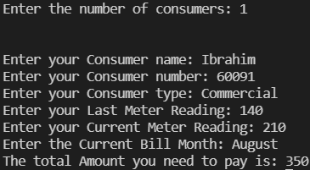

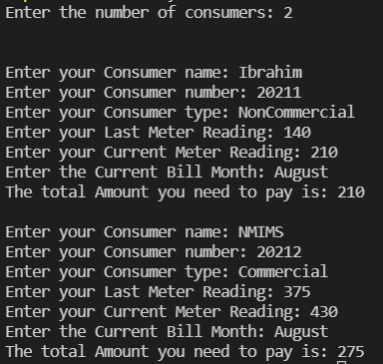

**Output for Problem Statement 2:**

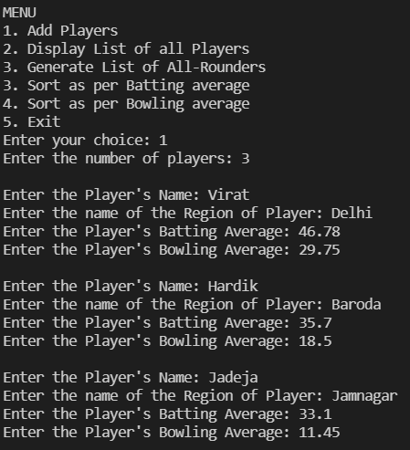

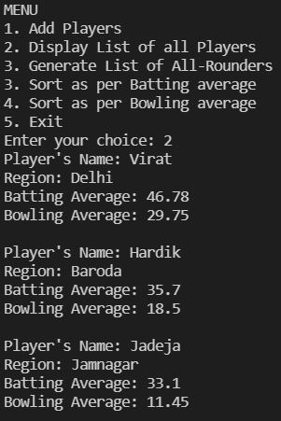

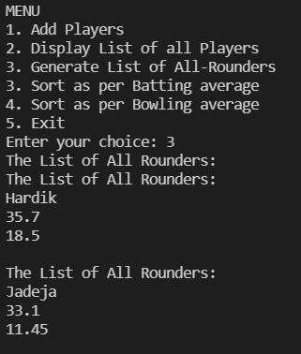

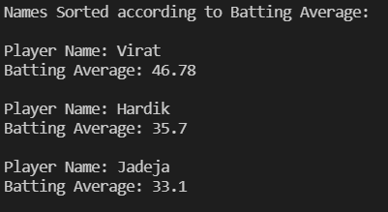

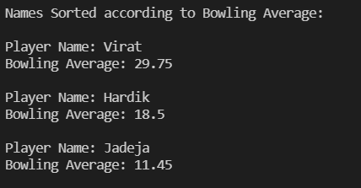

**LINK FOR THE CODE:** Done using VSCode